Template for OWTNM26 abstract (14 pt bold)

A. Author1,*,, B. Author1, C. Author2 (12 pt)  
1Laboratory, University, City, Postal Code, Country(11 pt italic)

2Group, Institute, Town, Postal Code, Country (11 pt italic)

*[presenting.author@epfl.ch](mailto:presenting.author@epfl.ch)

To ensure a reasonably uniform appearance of the papers in the proceedings volume, we ask all authors to follow these formatting instructions. Be aware that your paper will appear online.

The expected and maximum length of the contribution is 1 page. Prepare the document for A4 paper size, with margins of 2 cm (sides), and of 2.5 cm and 3.2 cm (top and bottom). Application of a single font of the type Times New Roman throughout the whole paper is strongly recommended. The authors’ name(s), affiliation(s) and the e-mail address of the corresponding author should be centered and placed 12 pt below the title. Maximum 1 Figure could be included and cited in the paper as (Fig. 1). The abstract (11 pt font size) has to be placed 12 pt below the affiliations and e-mail address(es). The text of the contribution should then follow single-spaced, of 12 pt size. References should be formatted as shown below [1,2]. Displayed equations should be centered**:**

$$E\left(x,z\right)=Ψ\left(x\right) \exp\left(-iβz\right).$$

Number figures, tables, and equations only when actually required.

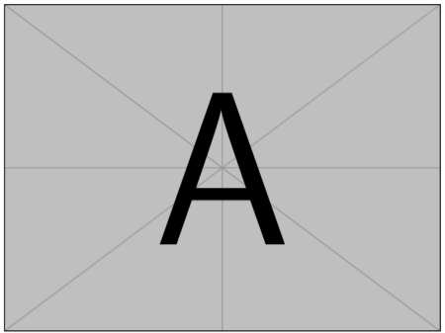

**Fig. 1.** The recommended font size is 11 pt (normal) for the figure caption.

Submit your paper in .pdf-format online at <https://owtnm26.epfl.ch/submission/>, before 8 February 2026.

References

1. D. Michaelis, F. Lederer, “An Example of a Properly Formatted Abstract for the OWTNM 2009 Workshop”, OWTNM 2009, Jena, Germany (2009).
2. A. Hername, B. Hisname, “Title of the publication”, Abbrev. J. **Vol.**, Firstpage (Year).